# Database:

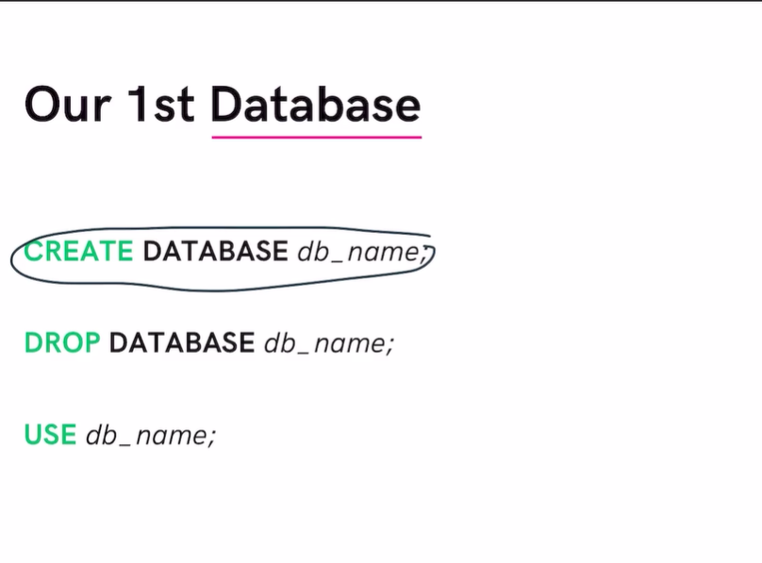

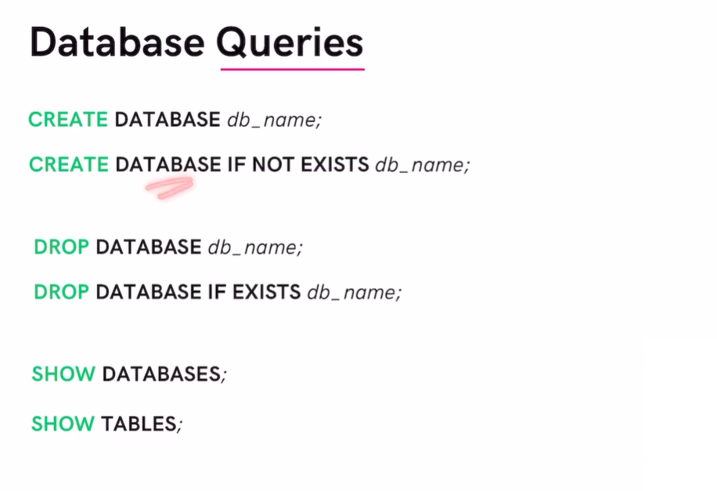

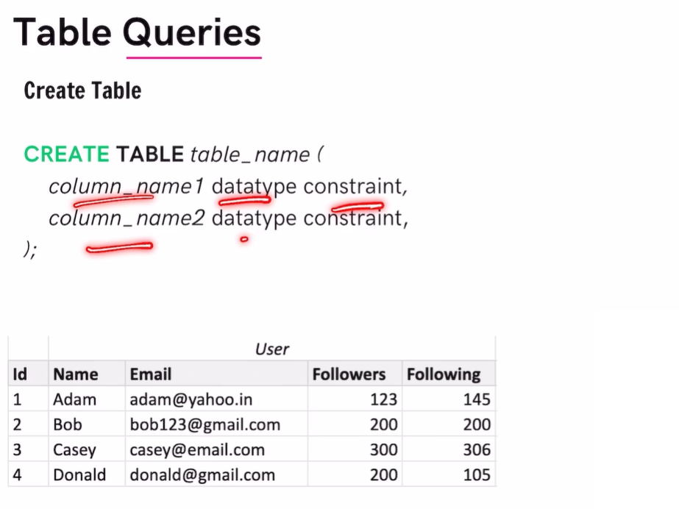

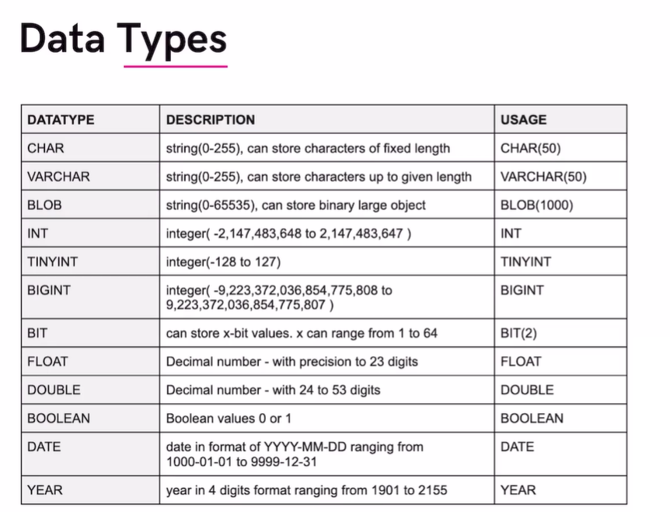

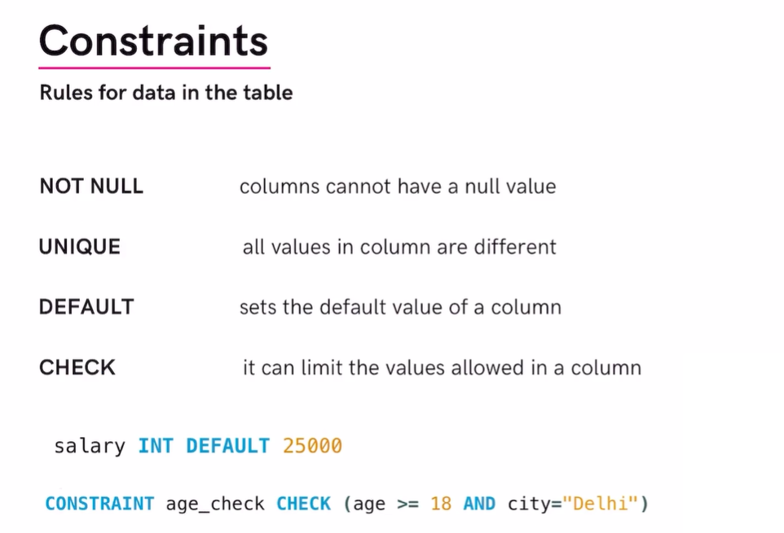

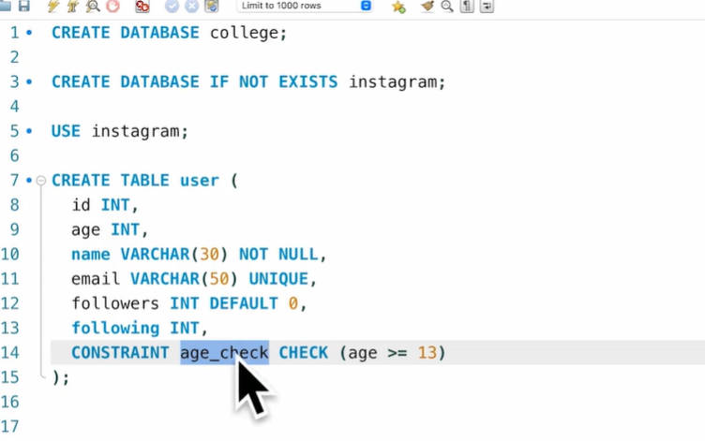

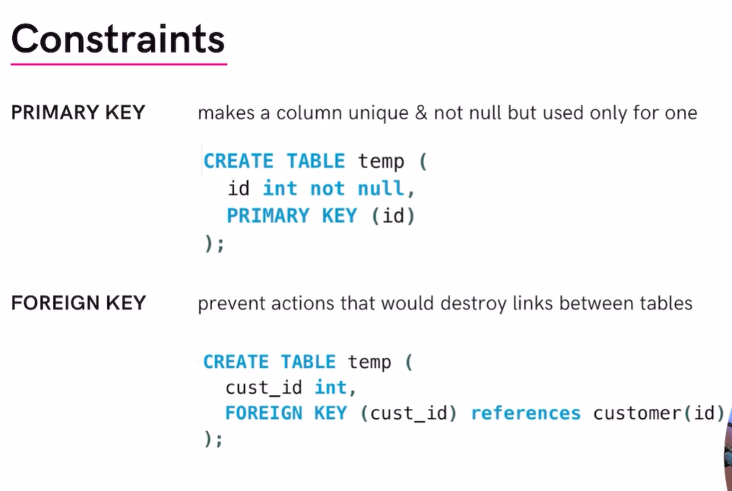

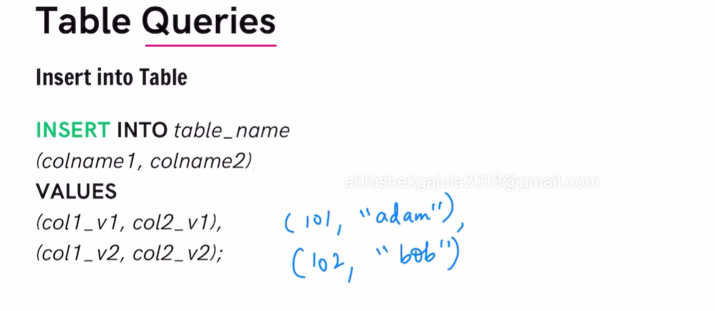

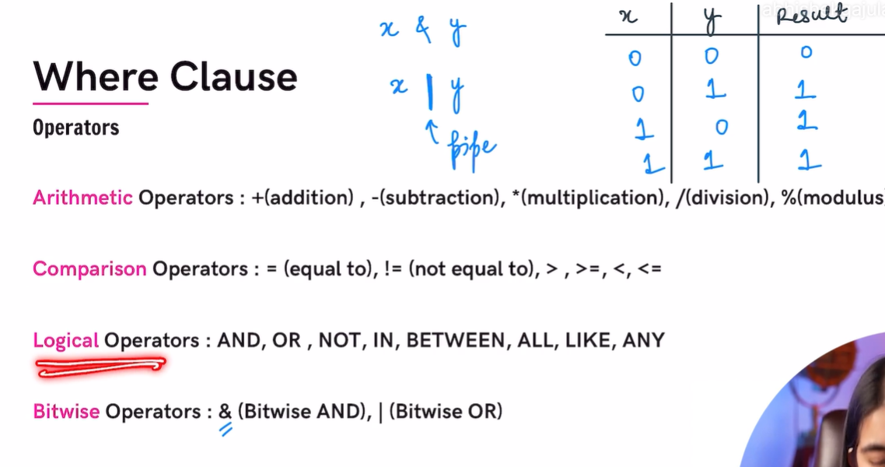

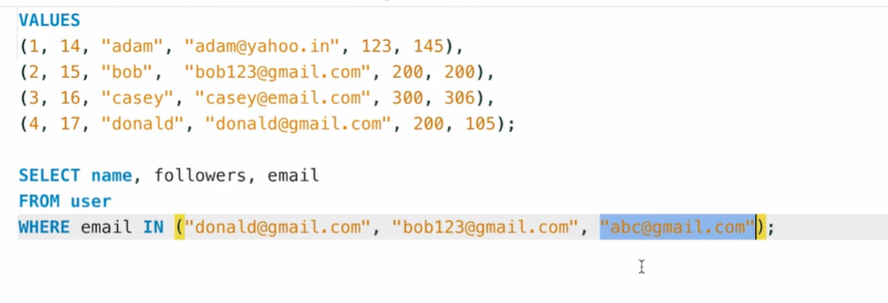

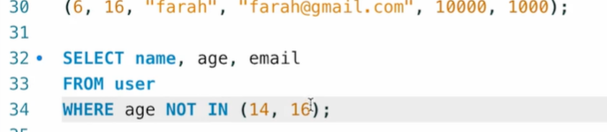

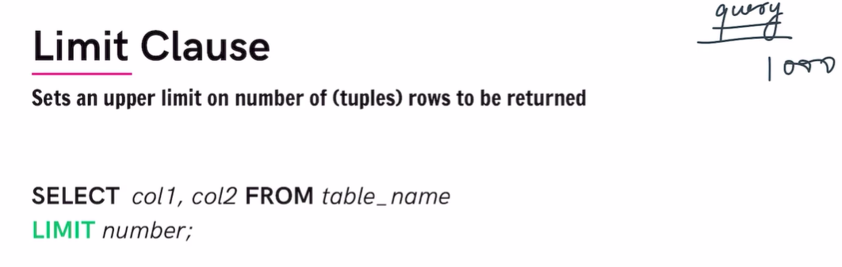

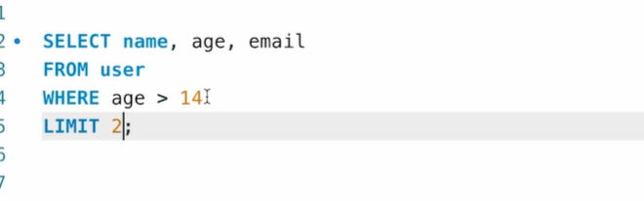

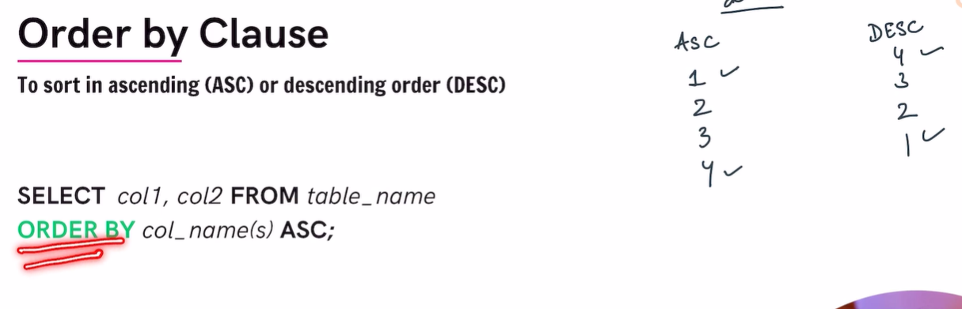

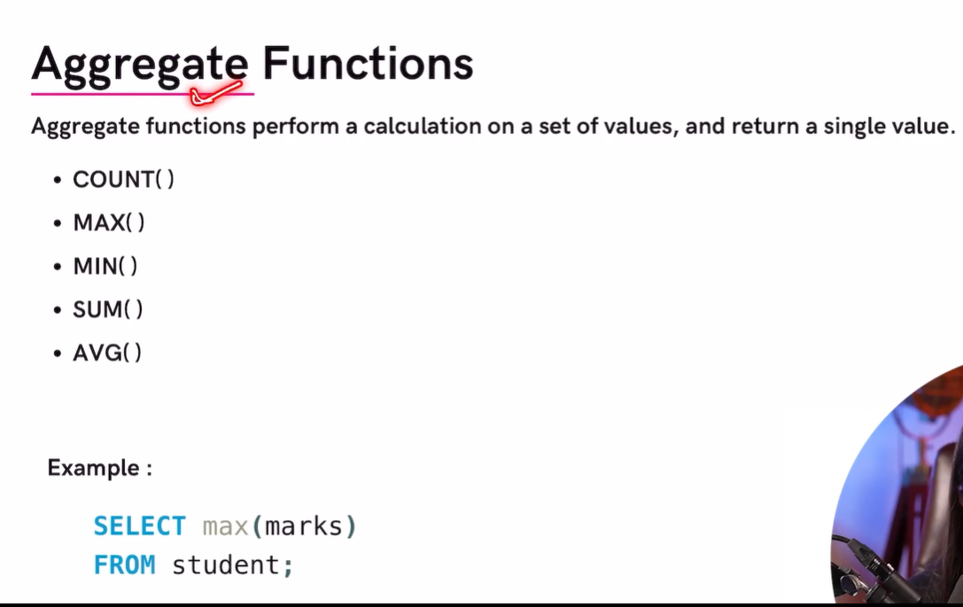

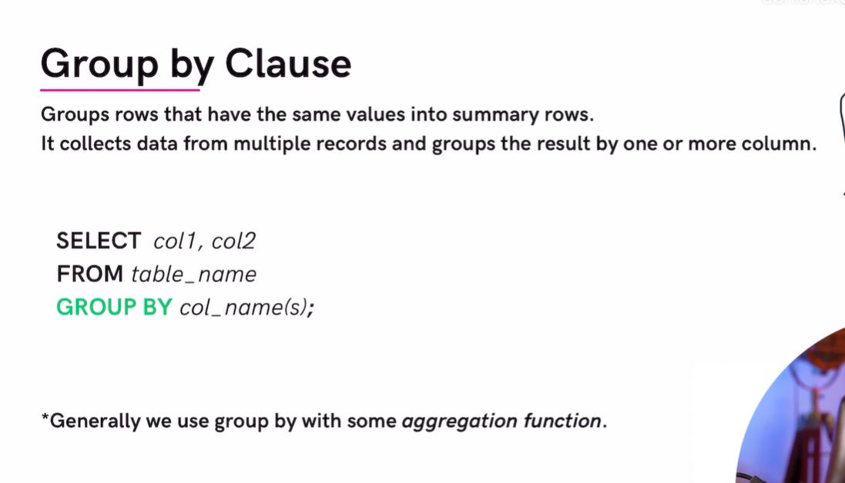

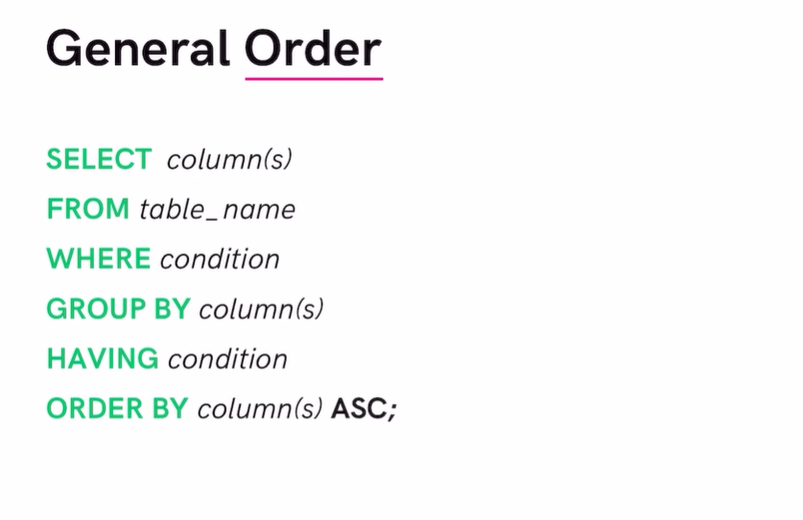

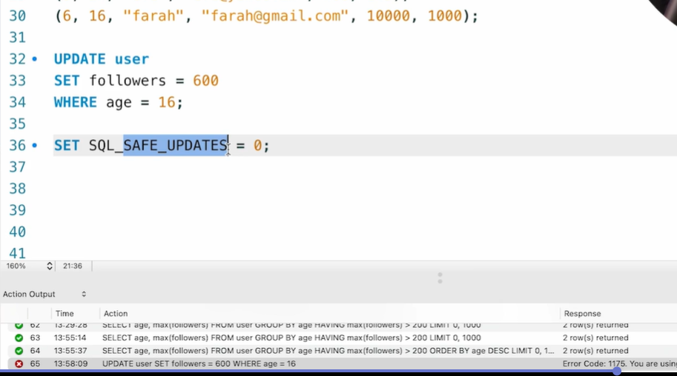

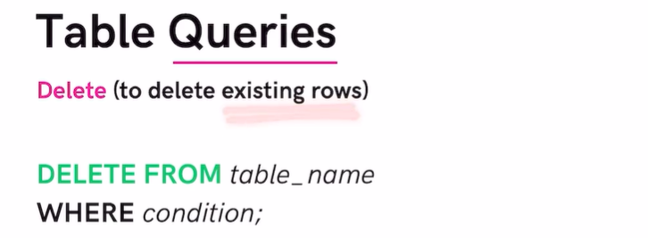

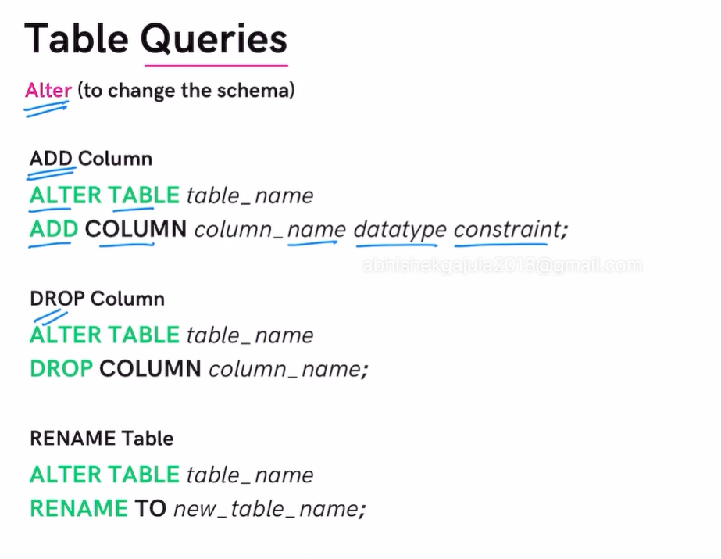

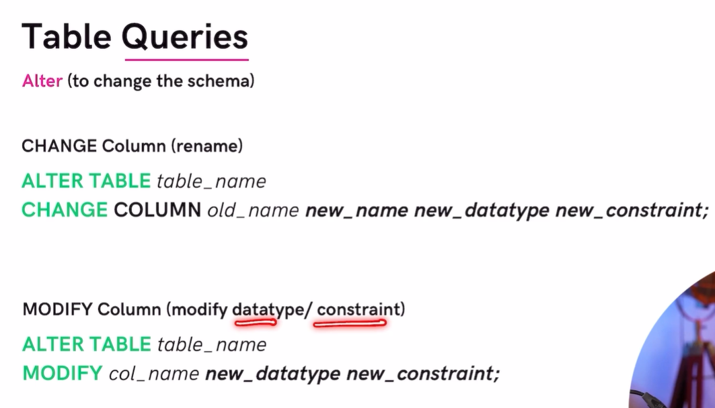

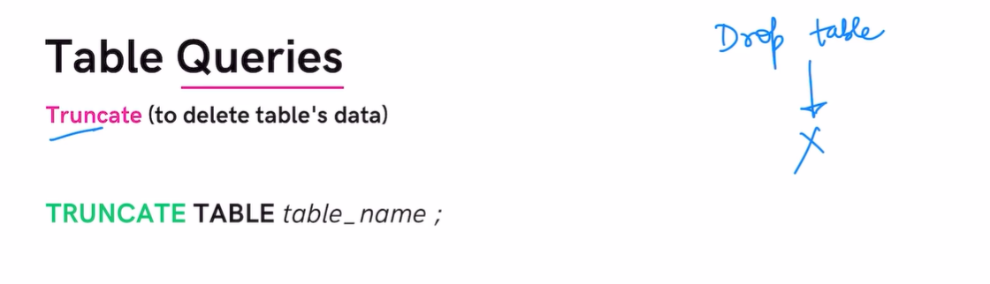

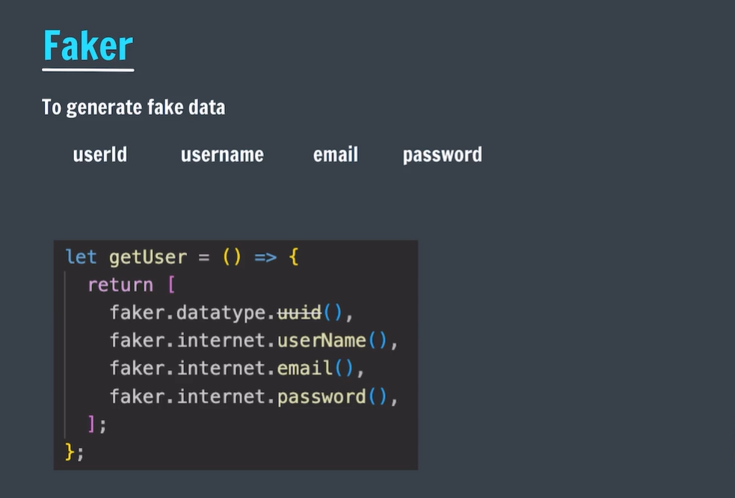

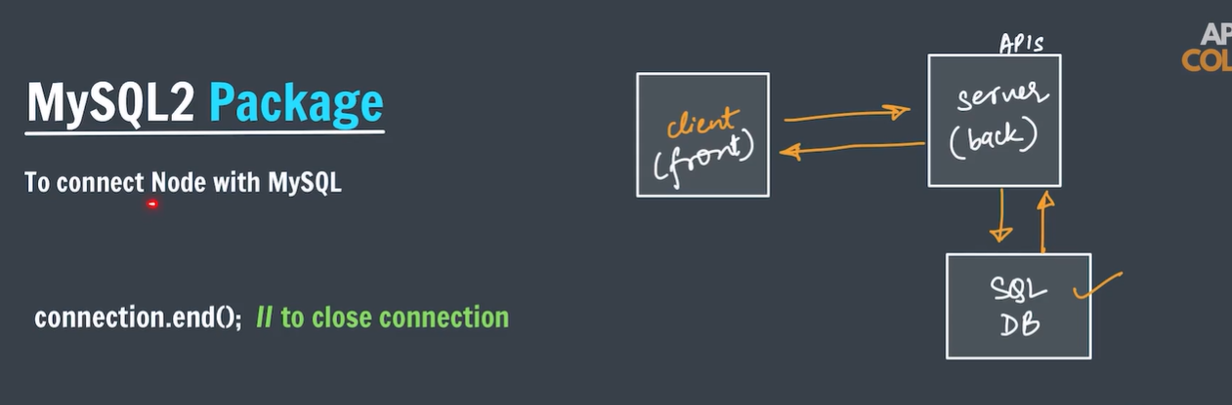

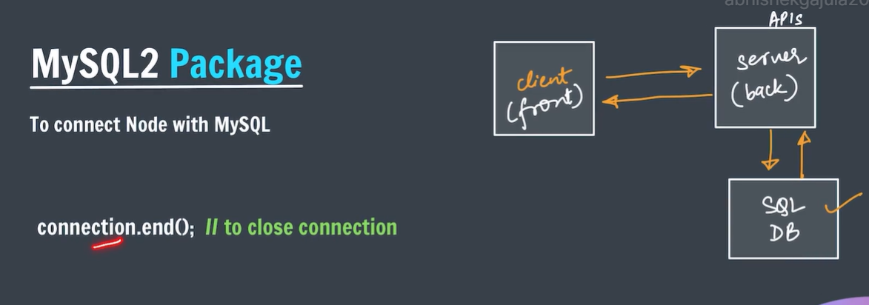

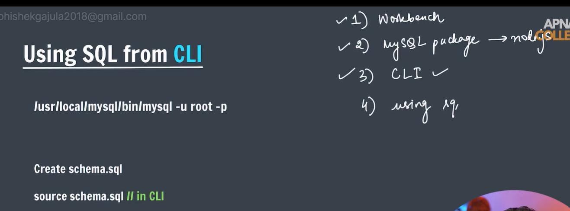

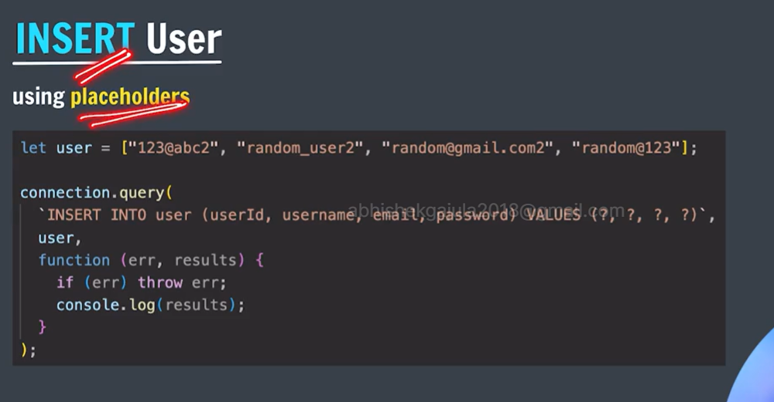

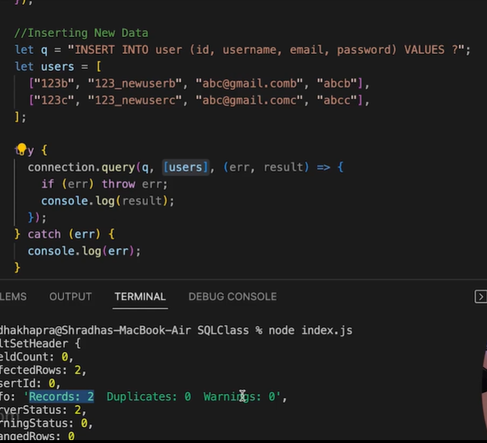

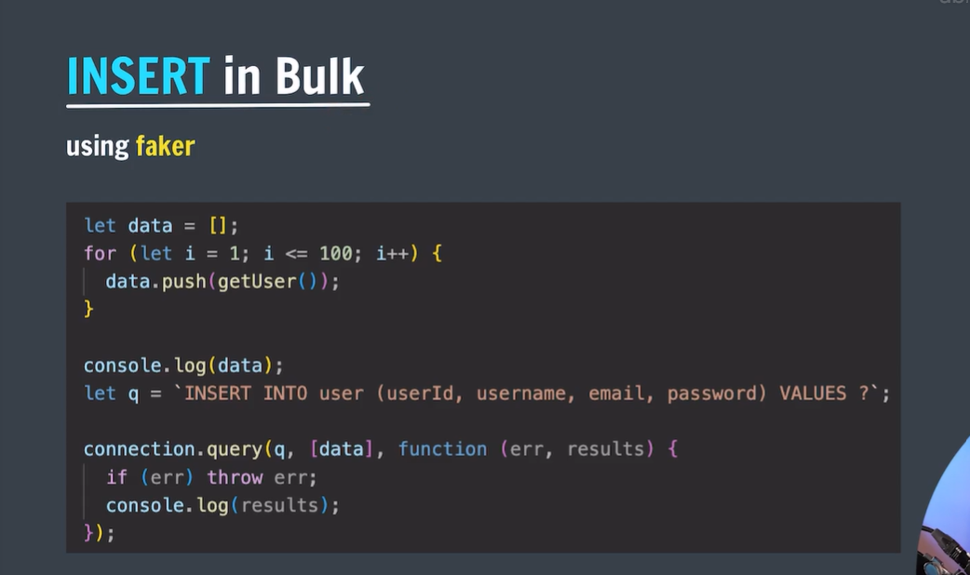

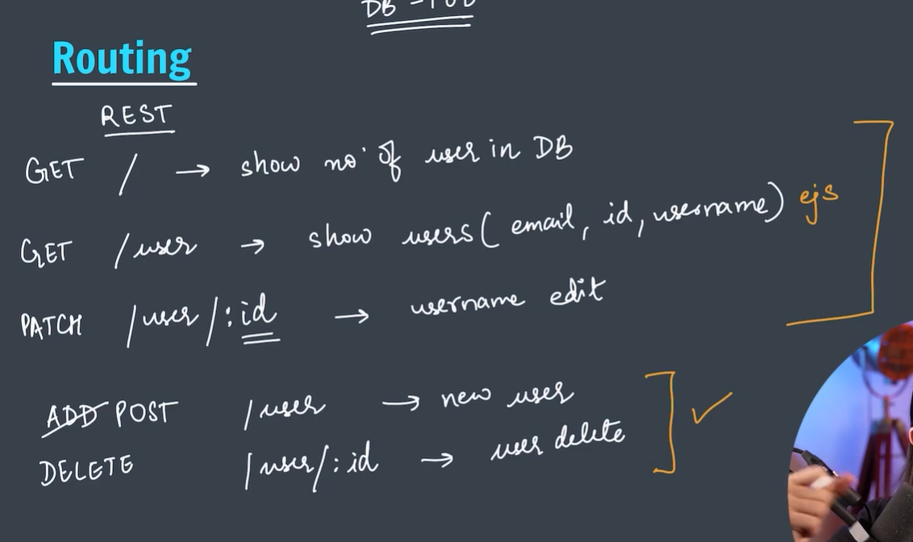

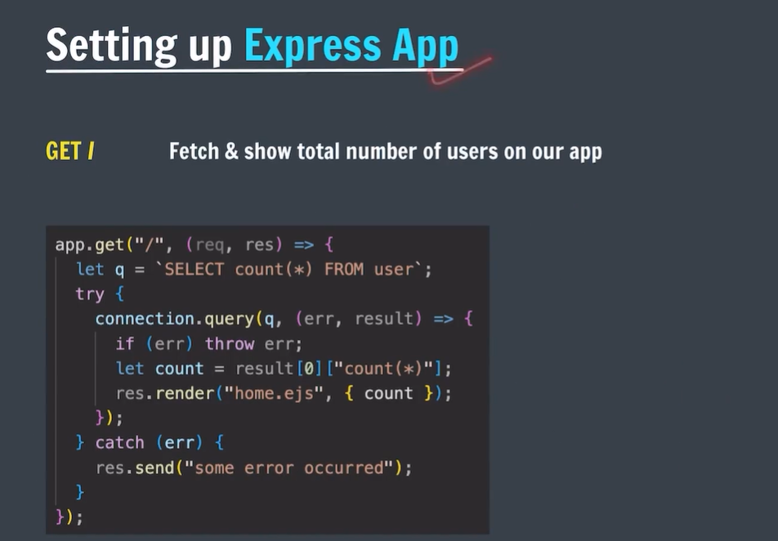

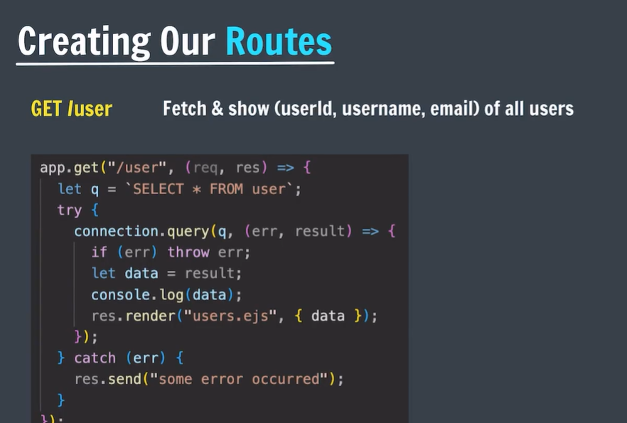

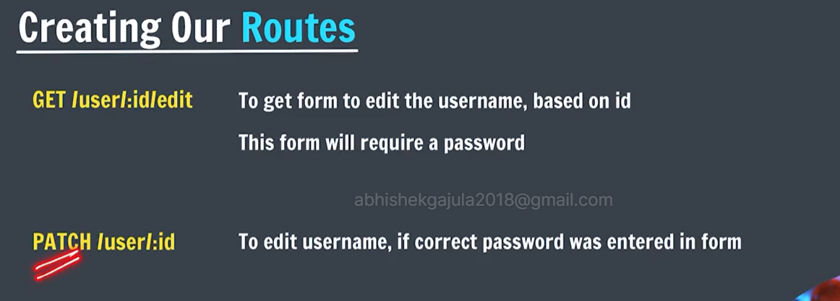

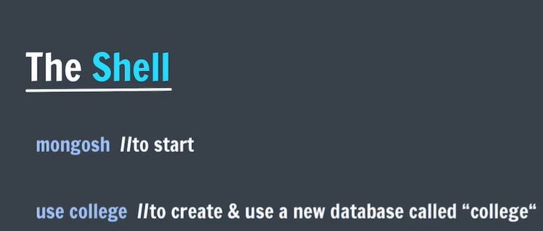

* Mongo shell can also run js code.
* Help:

test> help

Shell Help:

use Set current database

show 'show databases'/'show dbs': Print a list of all available databases.

'show collections'/'show tables': Print a list of all collections for current database.

'show profile': Prints system.profile information.

'show users': Print a list of all users for current database.

'show roles': Print a list of all roles for current database.

'show log <type>': log for current connection, if type is not set uses 'global'

'show logs': Print all logs.

exit Quit the MongoDB shell with exit/exit()/.exit

quit Quit the MongoDB shell with quit/quit()

Mongo Create a new connection and return the Mongo object. Usage: new Mongo(URI, options [optional])

connect Create a new connection and return the Database object. Usage: connect(URI, username [optional], password [optional])

it result of the last line evaluated; use to further iterate

version Shell version

load Loads and runs a JavaScript file into the current shell environment

enableTelemetry Enables collection of anonymous usage data to improve the mongosh CLI

disableTelemetry Disables collection of anonymous usage data to improve the mongosh CLI

passwordPrompt Prompts the user for a password

sleep Sleep for the specified number of milliseconds

print Prints the contents of an object to the output

printjson Alias for print()

convertShardKeyToHashed Returns the hashed value for the input using the same hashing function as a hashed index.

cls Clears the screen like console.clear()

isInteractive Returns whether the shell will enter or has entered interactive mode

For more information on usage: https://docs.mongodb.com/manual/reference/method

test>



* In mongodb if any db which doesn’t contain data is eliminated.
* Use command will create db if it not exist or if db exist then it will use it. 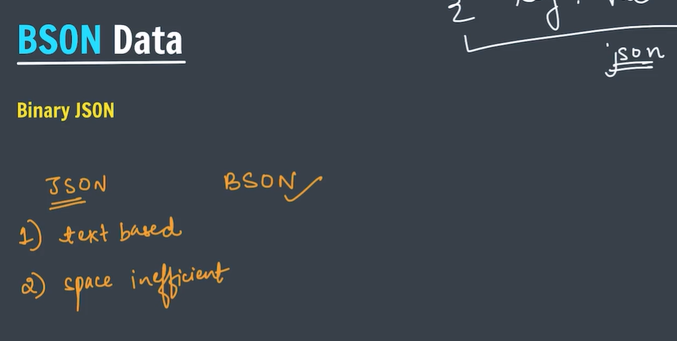

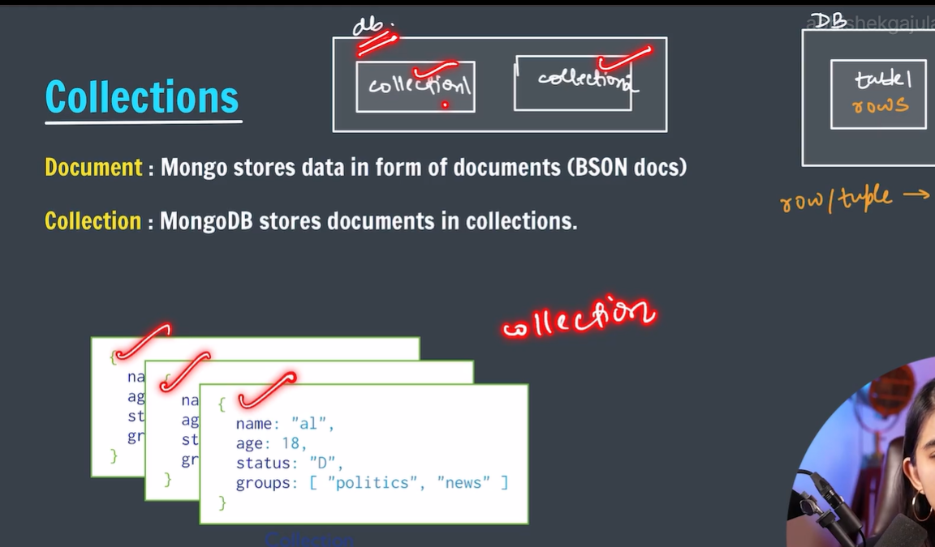

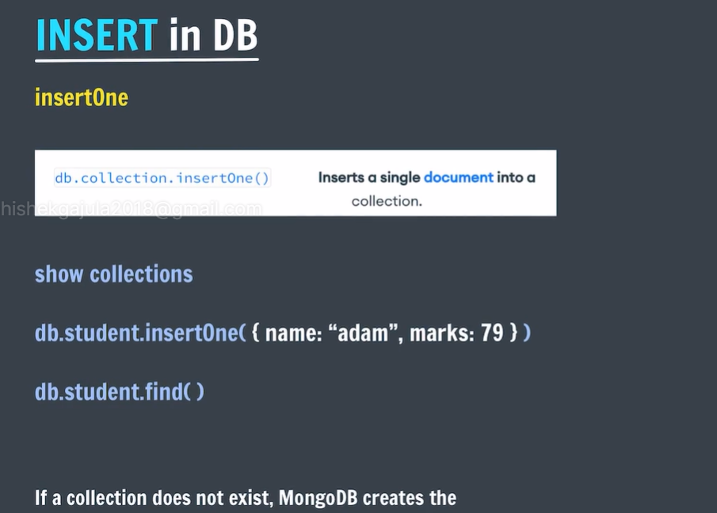

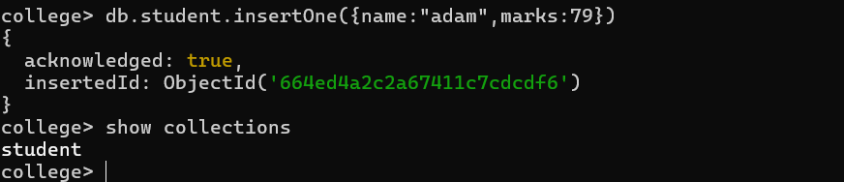

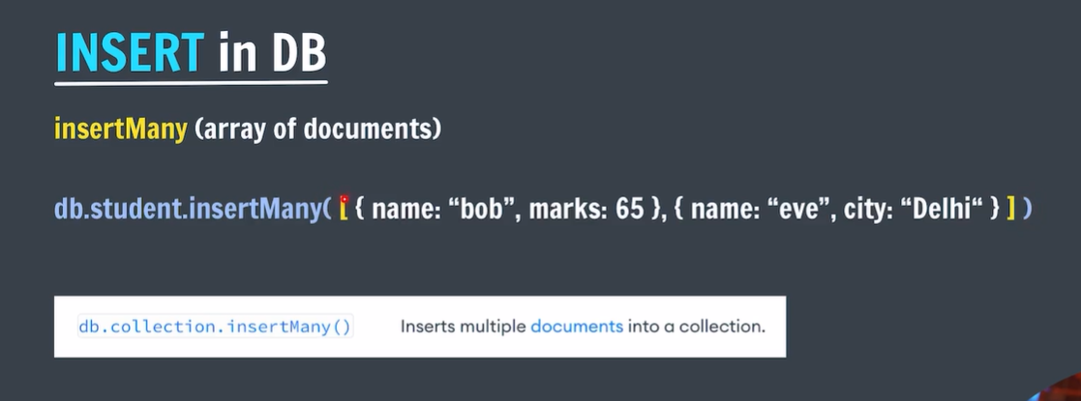

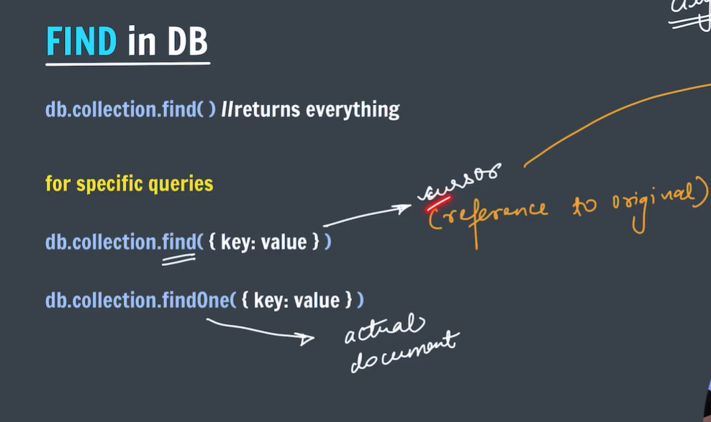

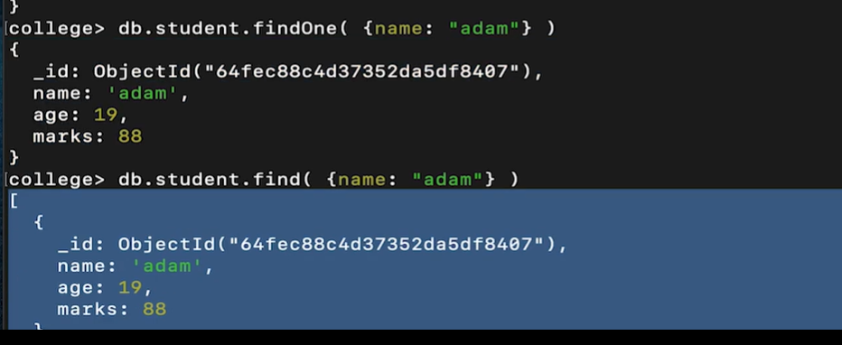

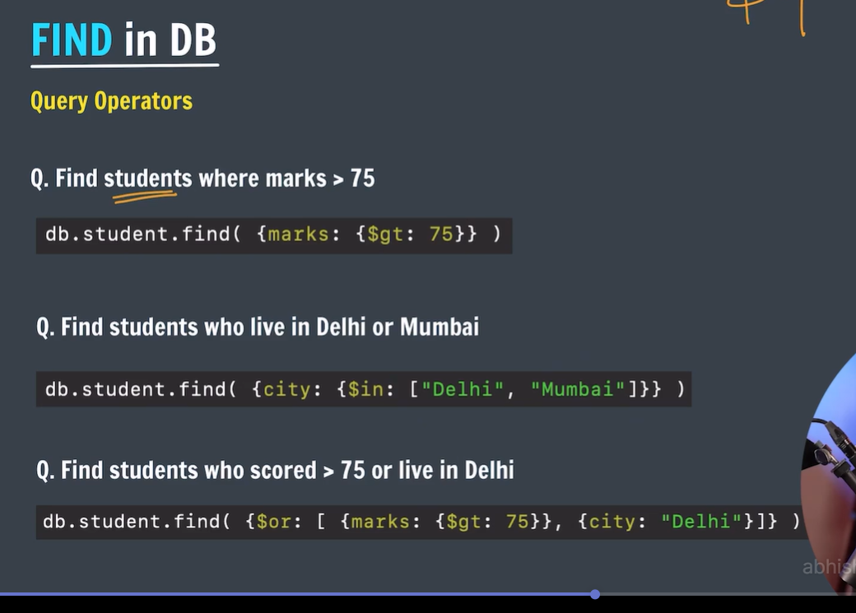

## **Query Selectors**

### Comparison

For comparison of different BSON type values, see the [specified BSON comparison order.](https://www.mongodb.com/docs/manual/reference/bson-type-comparison-order/#std-label-bson-types-comparison-order)

| **Name** | **Description** |
| --- | --- |
| [$eq](https://www.mongodb.com/docs/manual/reference/operator/query/eq/#mongodb-query-op.-eq) | Matches values that are equal to a specified value. |
| [$gt](https://www.mongodb.com/docs/manual/reference/operator/query/gt/#mongodb-query-op.-gt) | Matches values that are greater than a specified value. |
| [$gte](https://www.mongodb.com/docs/manual/reference/operator/query/gte/#mongodb-query-op.-gte) | Matches values that are greater than or equal to a specified value. |
| [$in](https://www.mongodb.com/docs/manual/reference/operator/query/in/#mongodb-query-op.-in) | Matches any of the values specified in an array. |
| [$lt](https://www.mongodb.com/docs/manual/reference/operator/query/lt/#mongodb-query-op.-lt) | Matches values that are less than a specified value. |
| [$lte](https://www.mongodb.com/docs/manual/reference/operator/query/lte/#mongodb-query-op.-lte) | Matches values that are less than or equal to a specified value. |
| [$ne](https://www.mongodb.com/docs/manual/reference/operator/query/ne/#mongodb-query-op.-ne) | Matches all values that are not equal to a specified value. |
| [$nin](https://www.mongodb.com/docs/manual/reference/operator/query/nin/#mongodb-query-op.-nin) | Matches none of the values specified in an array. |

### Logical

| **Name** | **Description** |
| --- | --- |
| [$and](https://www.mongodb.com/docs/manual/reference/operator/query/and/#mongodb-query-op.-and) | Joins query clauses with a logical AND returns all documents that match the conditions of both clauses. |
| [$not](https://www.mongodb.com/docs/manual/reference/operator/query/not/#mongodb-query-op.-not) | Inverts the effect of a query expression and returns documents that do not match the query expression. |
| [$nor](https://www.mongodb.com/docs/manual/reference/operator/query/nor/#mongodb-query-op.-nor) | Joins query clauses with a logical NOR returns all documents that fail to match both clauses. |
| [$or](https://www.mongodb.com/docs/manual/reference/operator/query/or/#mongodb-query-op.-or) | Joins query clauses with a logical OR returns all documents that match the conditions of either clause. |
|  |  |

# **Update Documents**

The MongoDB shell provides the following methods to update documents in a collection:

* To update a single document, use [db.collection.updateOne().](https://www.mongodb.com/docs/manual/reference/method/db.collection.updateOne/#mongodb-method-db.collection.updateOne)
* To update multiple documents, use [db.collection.updateMany().](https://www.mongodb.com/docs/manual/reference/method/db.collection.updateMany/#mongodb-method-db.collection.updateMany)
* To replace a document, use [db.collection.replaceOne().](https://www.mongodb.com/docs/manual/reference/method/db.collection.replaceOne/#mongodb-method-db.collection.replaceOne)

The examples on this page reference the Atlas [sample dataset](https://www.mongodb.com/docs/atlas/sample-data/). You can create a free Atlas cluster and populate that cluster with sample data to follow along with these examples. To learn more, see [Get Started with Atlas.](https://www.mongodb.com/docs/atlas/getting-started/)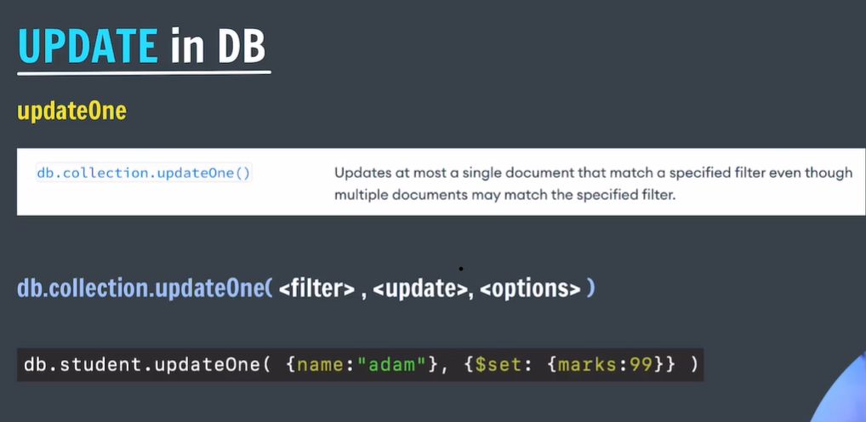

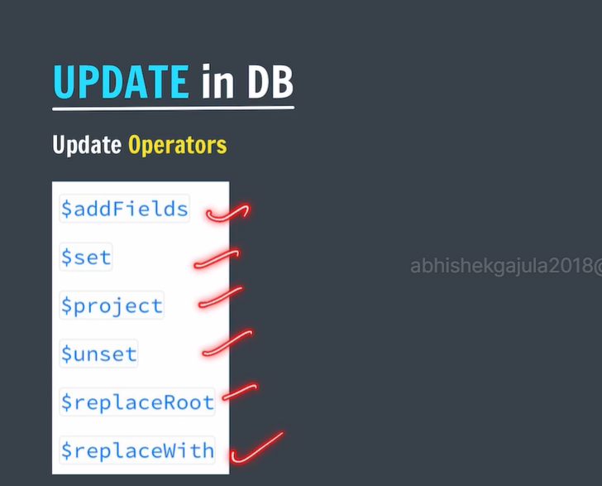

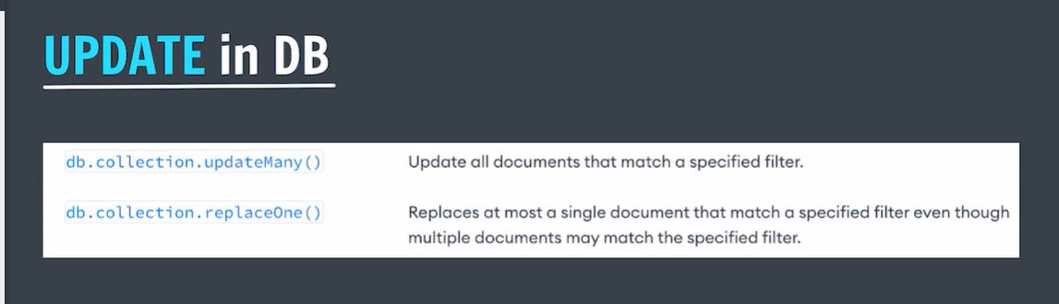

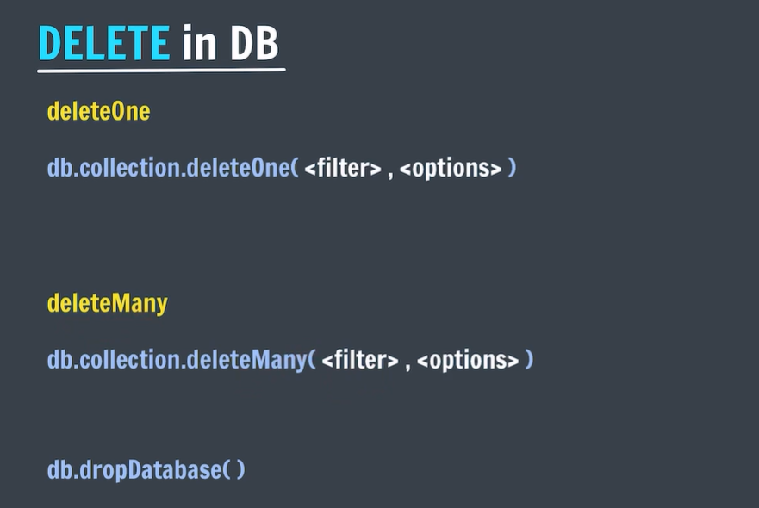

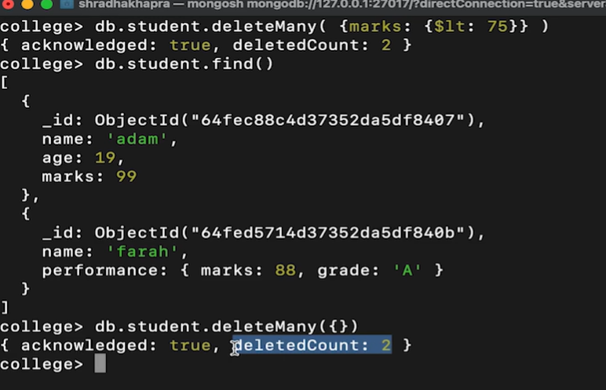

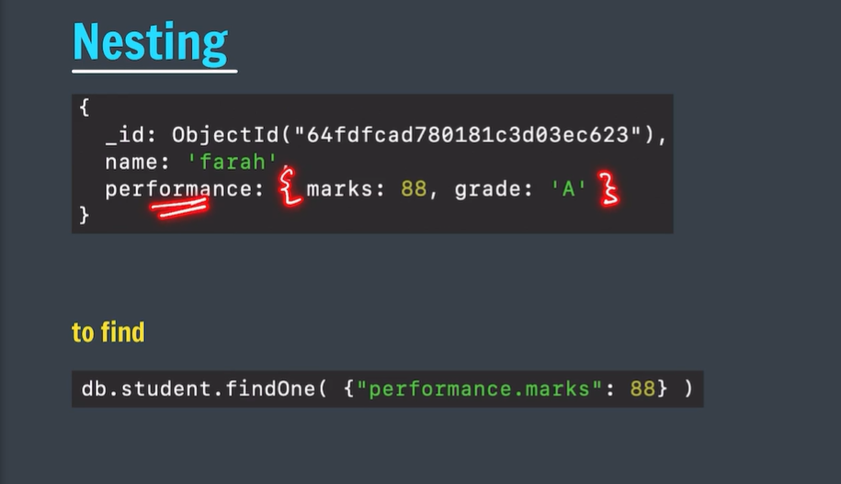

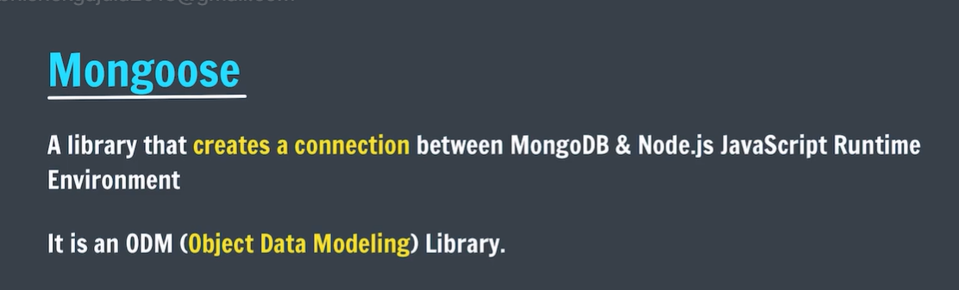



const mongoose = require('mongoose');

main().then(()=>{

    console.log("connections successful");

})

.catch(err => console.log(err));

async function main() {

  await mongoose.connect('mongodb://127.0.0.1:27017/test');

}

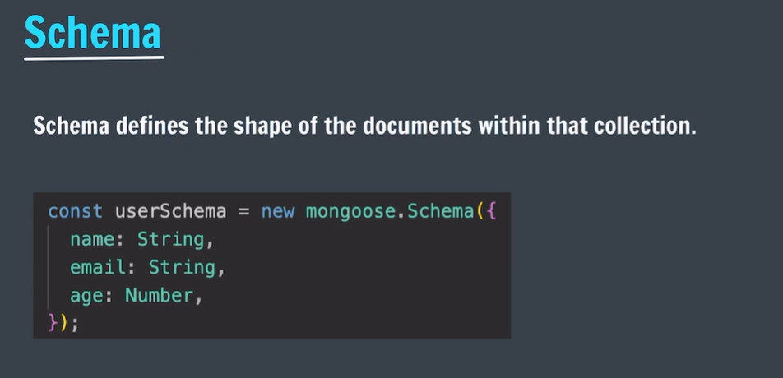

The permitted SchemaTypes are:

* [String](https://mongoosejs.com/docs/schematypes.html#strings)
* [Number](https://mongoosejs.com/docs/schematypes.html#numbers)
* [Date](https://mongoosejs.com/docs/schematypes.html#dates)
* [Buffer](https://mongoosejs.com/docs/schematypes.html#buffers)
* [Boolean](https://mongoosejs.com/docs/schematypes.html#booleans)
* [Mixed](https://mongoosejs.com/docs/schematypes.html#mixed)
* [ObjectId](https://mongoosejs.com/docs/schematypes.html#objectids)
* [Array](https://mongoosejs.com/docs/schematypes.html#arrays)
* [Decimal128](https://mongoosejs.com/docs/api/mongoose.html#mongoose_Mongoose-Decimal128)
* [Map](https://mongoosejs.com/docs/schematypes.html#maps)
* [UUID](https://mongoosejs.com/docs/schematypes.html#uuid)

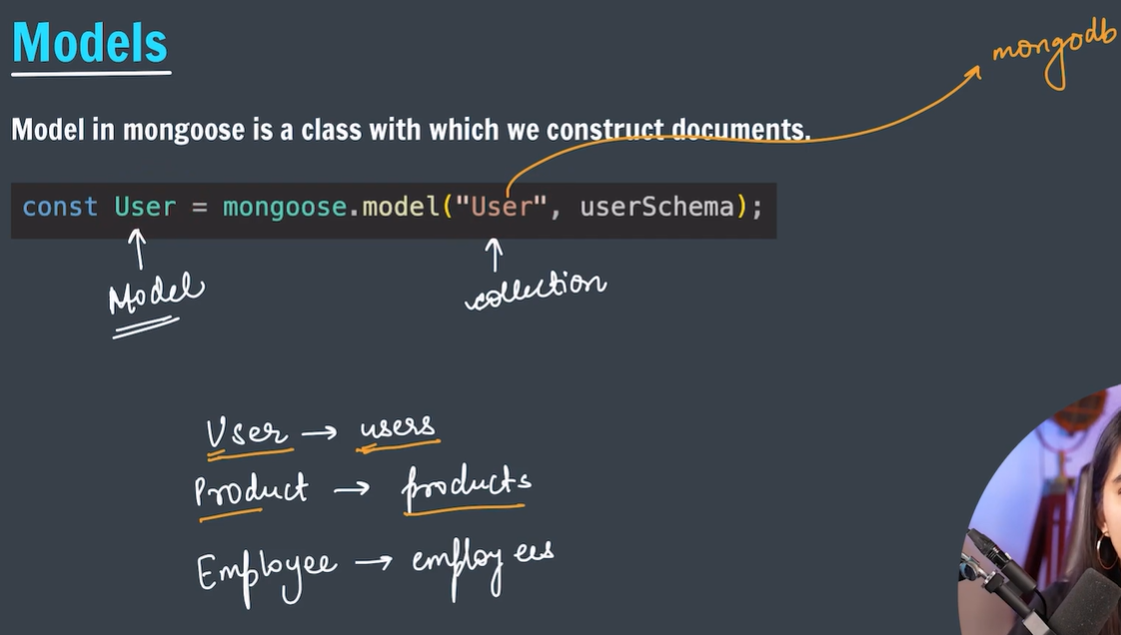

* If you write user in the model function it will be changed into users in mongo db.

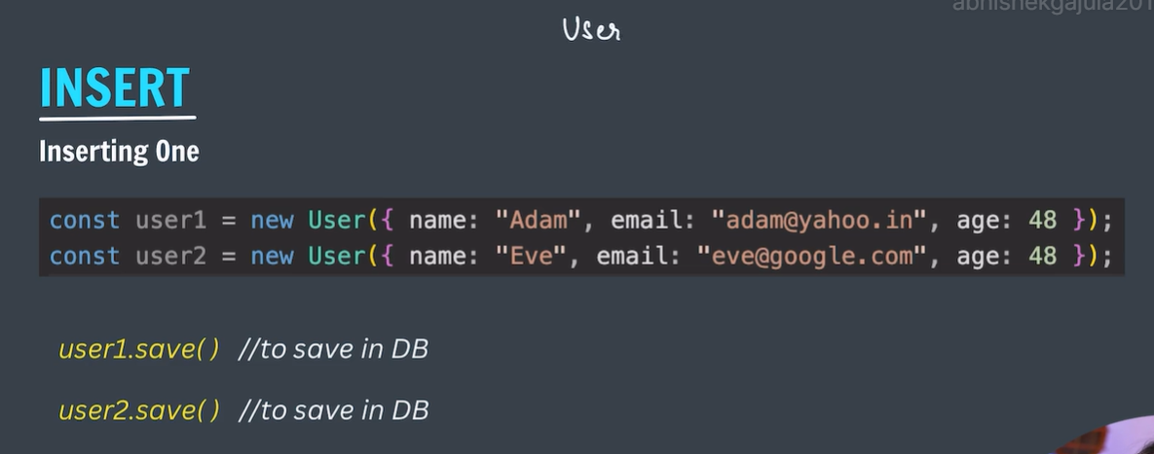

const User=mongoose.model("User",userSchema);

let user1=new User({

    name:"adam",

    email:"abc@gmail.com",

    age:48,

});

* It will store above object in own memory not in db.

PS F:\WEBDEVELOPMENT\backend\database\mongo> node

Welcome to Node.js v20.13.1.

Type ".help" for more information.

> .load index.js

const mongoose = require('mongoose');

main().then(()=>{

console.log("connections successful");

})

.catch(err => console.log(err));

async function main() {

await mongoose.connect('mongodb://127.0.0.1:27017/test');

}

const userSchema=mongoose.Schema({

name:String,

email:String,

age:Number

});

const User=mongoose.model("User",userSchema);

let user1=new User({

name:"adam",

email:"abc@gmail.com",

age:48,

});

Promise {

<pending>,

[Symbol(async_id_symbol)]: 112,

[Symbol(trigger_async_id_symbol)]: 111

}

> connections successful

> user1

{

name: 'adam',

email: 'abc@gmail.com',

age: 48,

_id: new ObjectId('664f1d6f028c2520f5a30d48')

}

>

> to add it in db we should use user1.save();

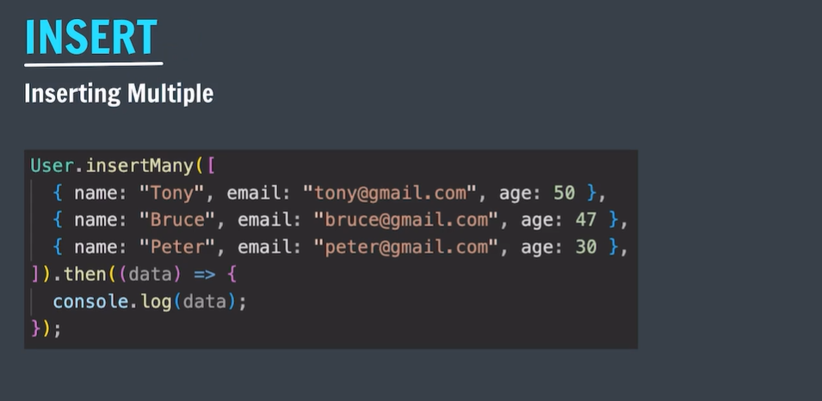

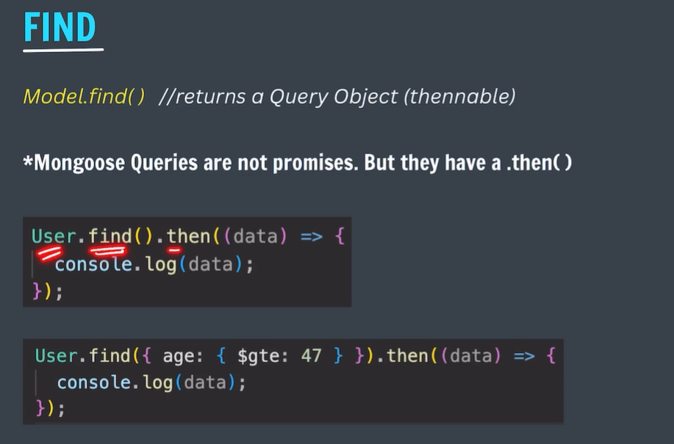

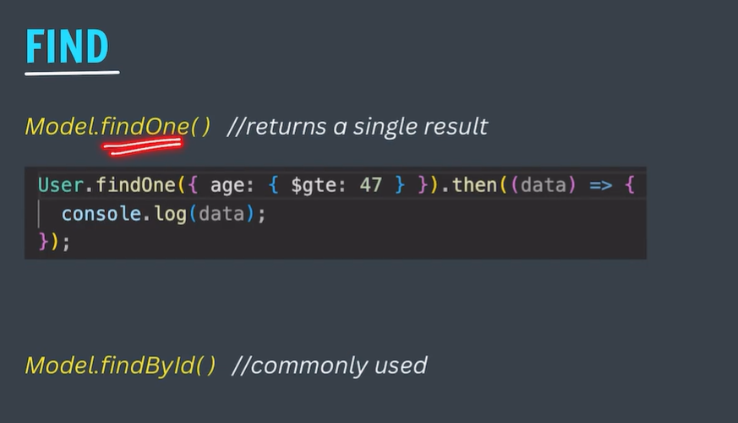

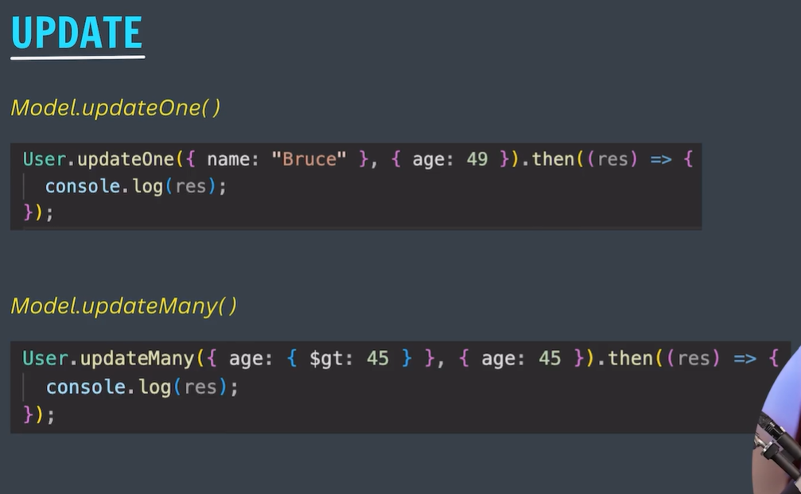

* These statements will return metadata about the updation.
* To have the values which are updated we have to use below function.

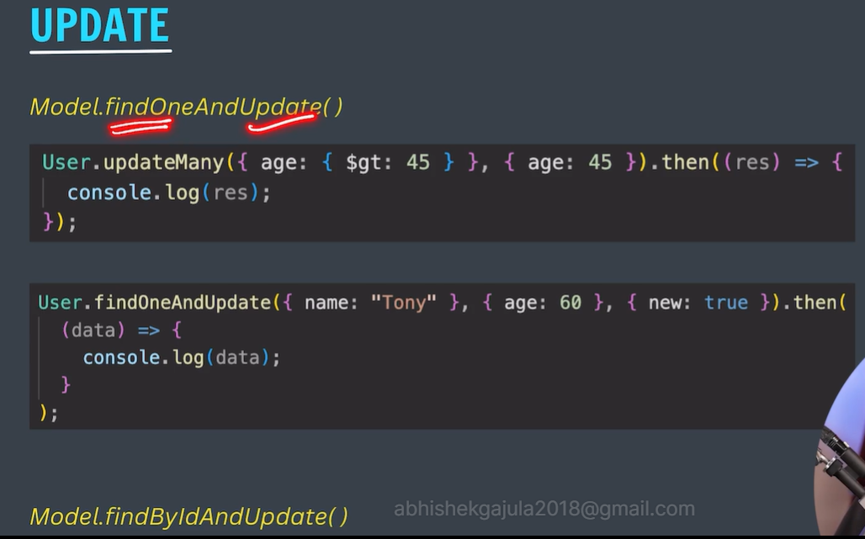

* But here returned objects are before updating the value.

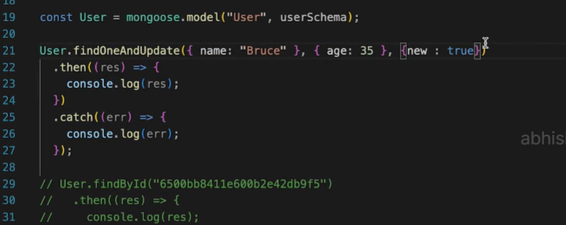

* Then it will return the modified documents rather than the original documents.

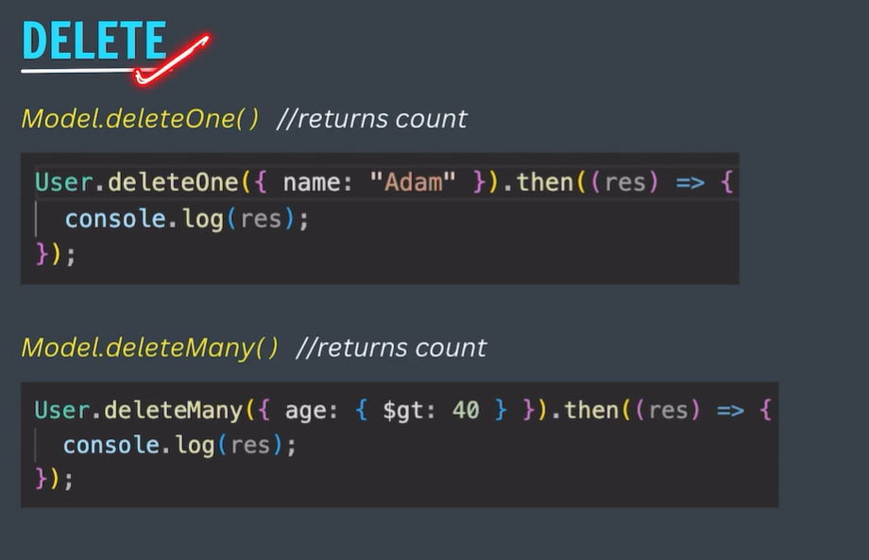

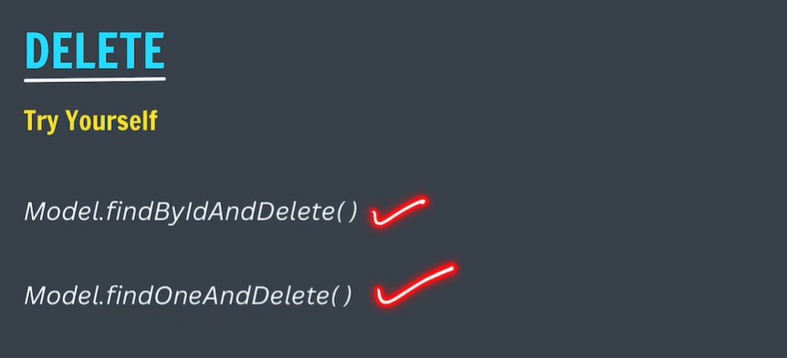

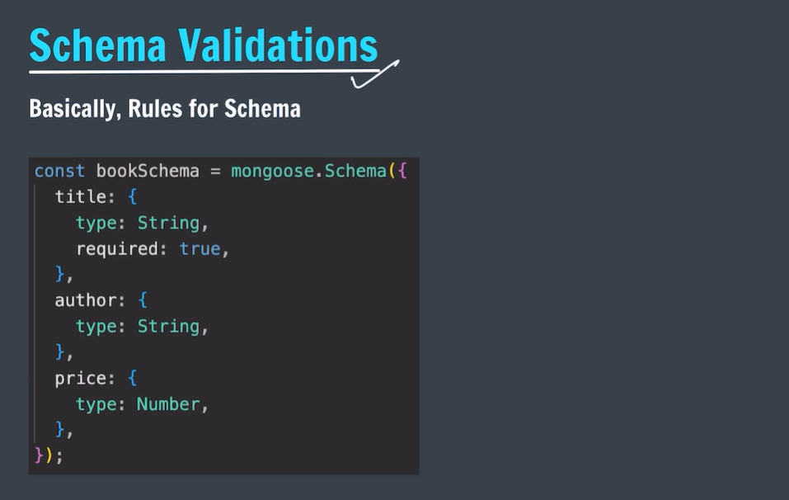

* YOU CAN MENTION ANY TYPE OF DATA IN JS FILE BUT IT WILL CONVERTED BY MONGODB .
* 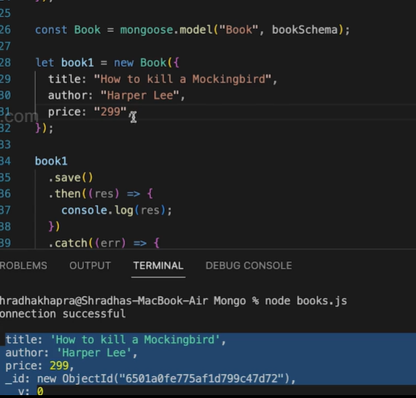

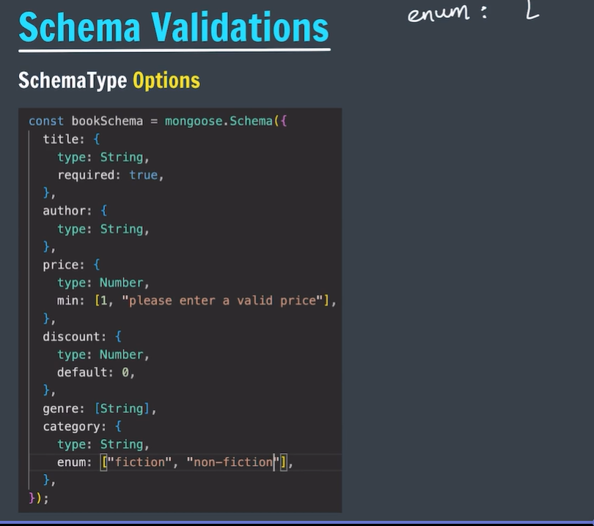

* The above validations will work only while insertions not while updations.

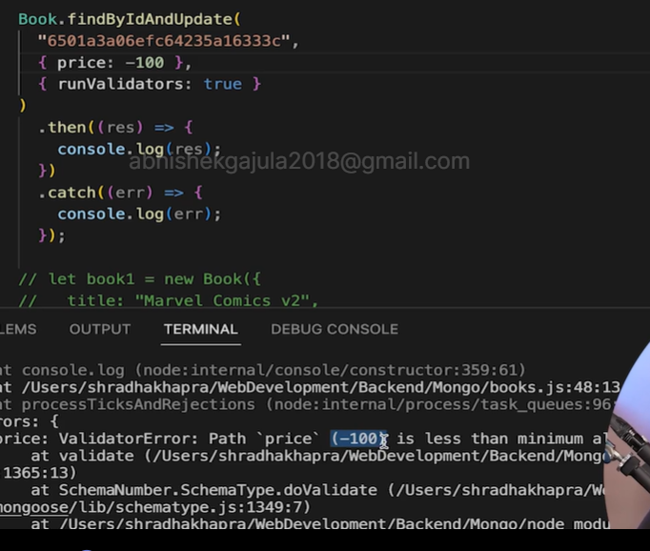

* To check the validation while updating we have to use above option.
* To specify a specific error if validation is not followed .

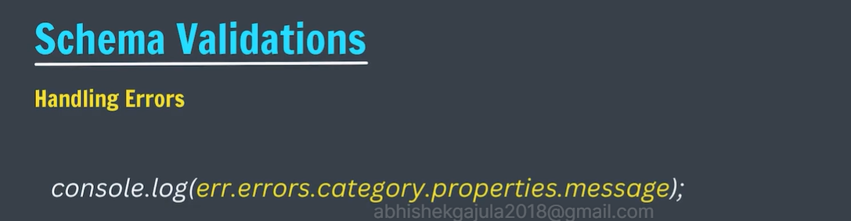

* If we are using “then” in the functions which will return promise then we don’t have to write await key word before the current function.

